**Creation of Return Lot**

**T Code:**  FP09

Step 1: Using the above T code navigate to the screen and create a new lot

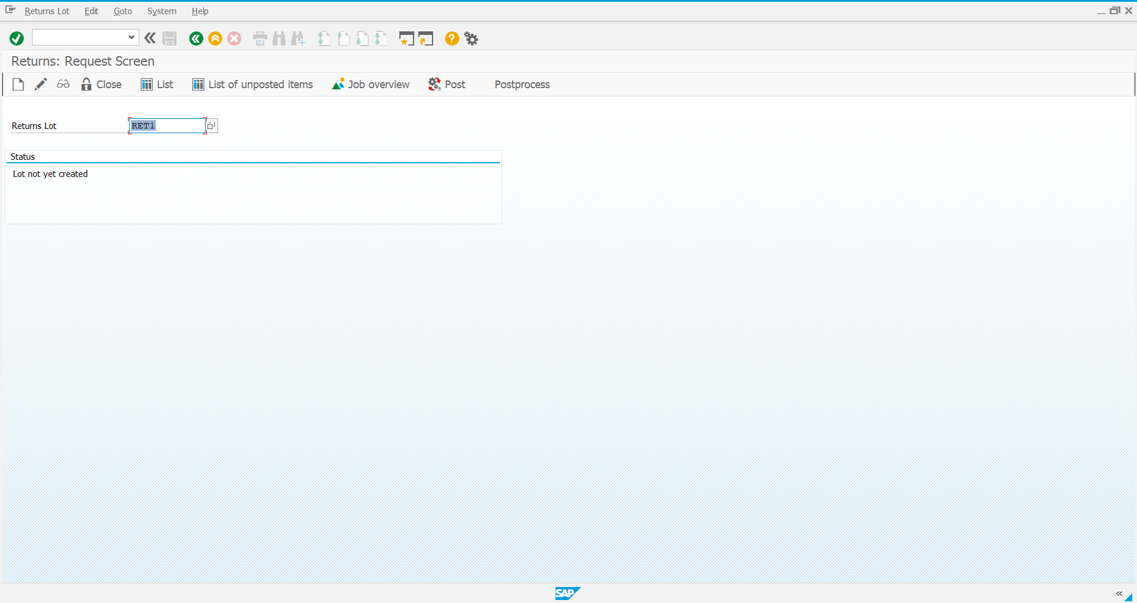

Step 2: Give the required details, save and select new items

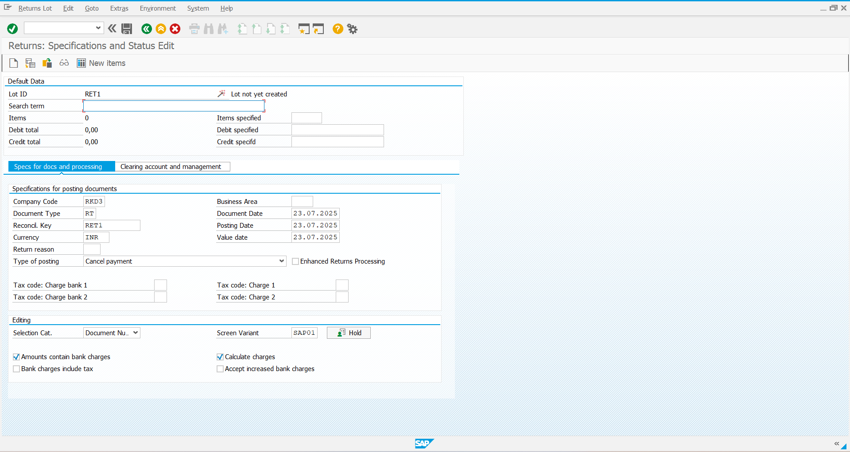

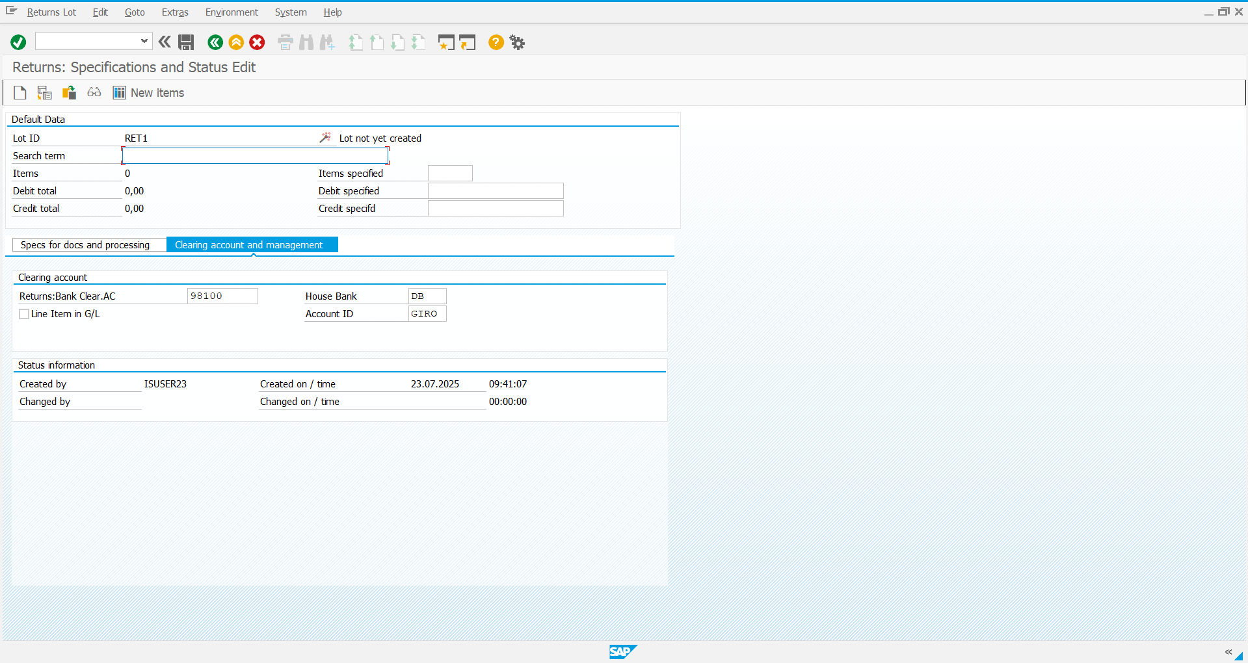

Step 3: Give the required details and save

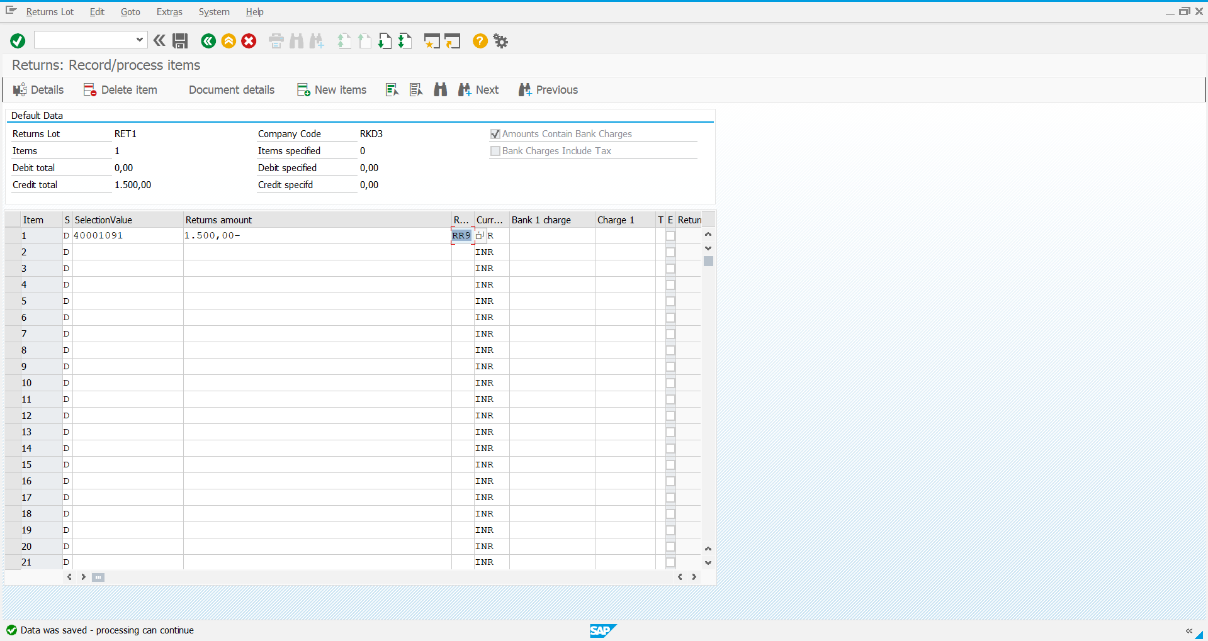

Step 4: Come back to the initial screen, Close the lot and post it

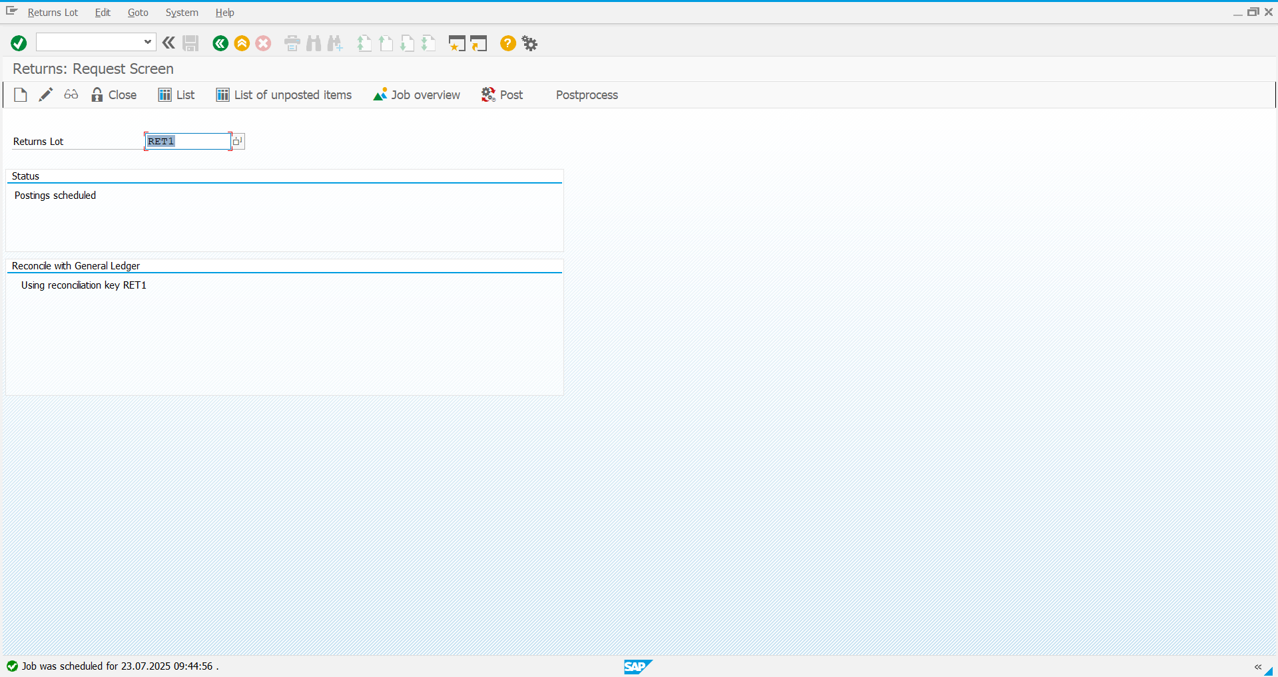

Step 5: Use the **T Code: FPL9** to perform an analysis on the Account Balance

